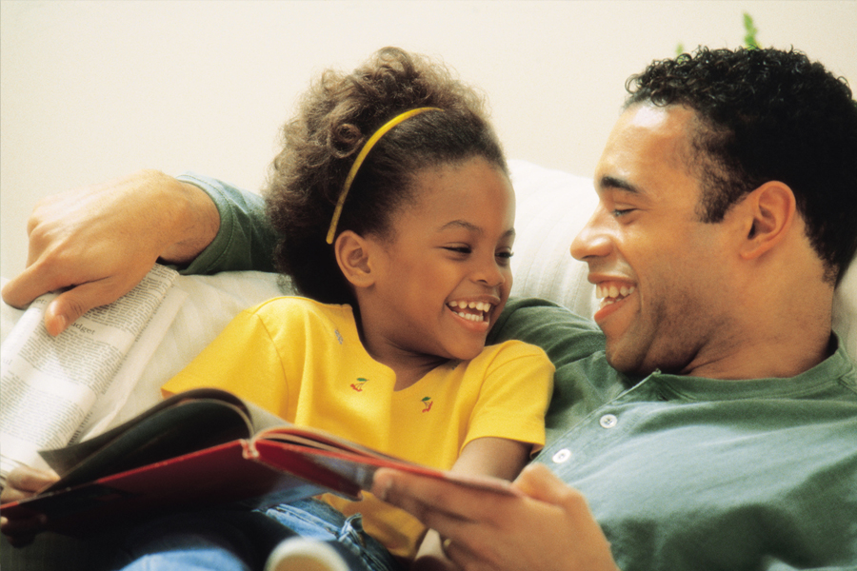

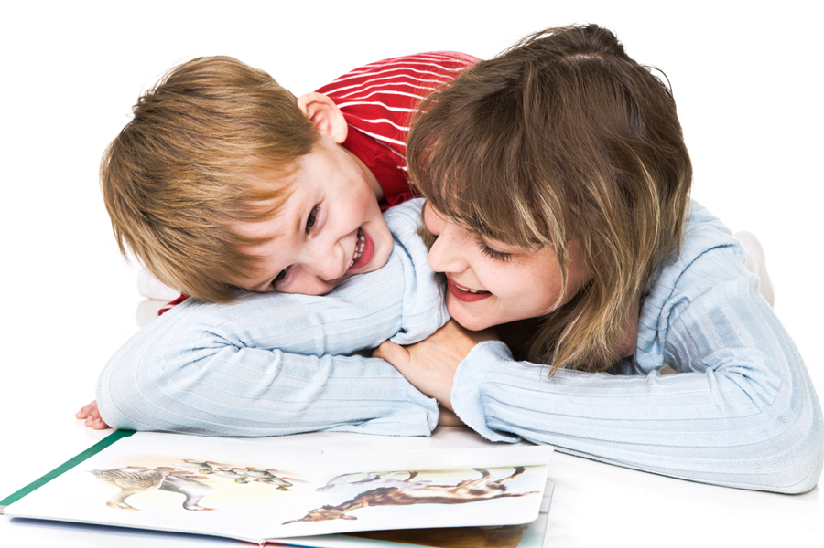

Let’s Take a Book Picture Walk

A picture walk helps develop your children’s language and pre-reading skills. The book picture walk allows you to find out what your child knows based on the pictures and encourages them to think about what they think might happen in the story.
You are not reading the book. You are encouraging your child to talk about the pictures.
Speak in the language that is most comfortable for YOU!

What to do:
- Look at the cover.
- Point to and say name of title, author, illustrator.
- Ask your child what he thinks the book is about.
- Without reading the words in the book, encourage your child to turn the pages one at a time.
- Talk about each picture. Allow time for your child to respond to what you say—5 seconds.
- Point to a picture and ask, questions such as:
  - What’s this?
  - What do you think is happening?
  - What is happening on this page?
  - Where do you think they are going?
  - What might happen next?
- Remember to take turns talking.
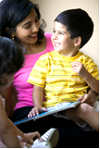
- Rephrase what your child says to help your child learn more language.
  - Introduce new words and what they mean.
  - Gently correct grammar simply by saying the sentence correctly.
- Add what you know to what your child says.
- Help your child make connections to past and future events.
  - When did you . . . ?
  - How did you feel when. . . ?
  - How would you feel if . . . ?

www.earlylit.net

So Many Ways to
Share a Book Together!

There are many ways to read books with your children. Children often like to hear the same book over and over again. You can share the same book in different ways each time you read it. Here are some ways you and your child can share books together.

- Encourage your child to turn the pages.
- Have your child tell a story from the pictures.
- Look at the pictures on one page. What do they make you and your child think about? Talk about them together.
- Read the story straight through to get the flow of the story. There may be short interactions with your child.
- Have your child join in with a repeated word or phrase.
- When reading books with repeated phrases or actions, or rhyming books, stop before the end of a line and let your child finish it.
- Ask questions to involve your child—“What do you think is happening here?”
- Ask open-ended questions: “What would you do if that happened to you? How would you feel? Why do you think happened?”
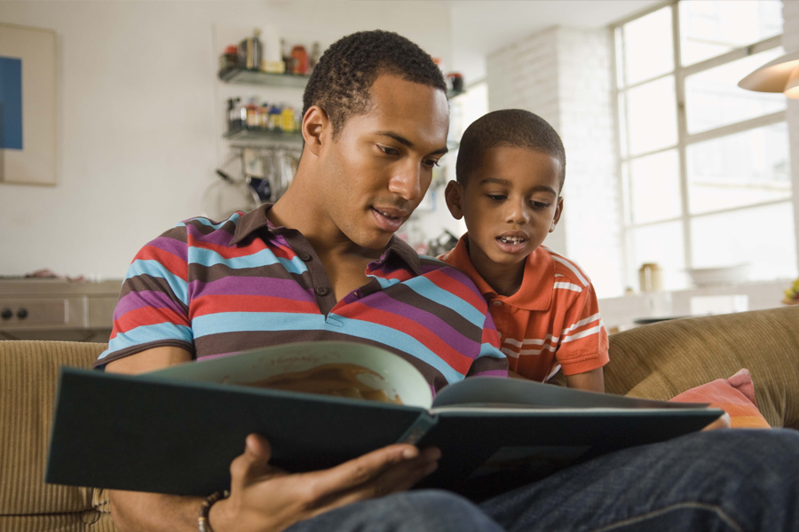
- Repeat what your child says. Add details and use new words.
- Talk about or explain words your child does not know.
- Wait for your child to ask questions or make comments.
- After reading the book, talk about what happened first, in the middle, last.
- After reading the book, talk about what your child said during the picture walk. Did the story end the way your child thought it would or did your child have another idea?
- Focus on the text
- Point to words in repeated phrase
- What does the font or layout of the text tell you?
- What letters do you notice?

