**Building on Children’s Curiosity:**

**Talking with Children to Support Science Thinking**

**Keep on having fun with science**

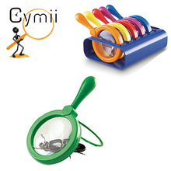

Even from birth we can develop children’s abstract thinking, the basis for science concepts by:

* Following your child’s lead, their interests
* Giving children time to figure things out
* Putting words to what they are looking at or playing with, adding descriptions
* Encouraging persistence and problem solving
* Using words for science concepts

**In today’s storytime,** we talked about the tools, one of the science concepts.

Helping children understand what a tool is, how we use them, and how they help us.

A tool is a device or utensil to carry out a particular function or that helps us accomplish a task.

Children can learn about tools like magnifying glasses, eyedroppers, thermometers, and other tools that help them with science.

**Science Concepts**

**Scientific Process Skills**

**Science Process Skills**

When we give children the chance to practice the skills listed below, we are helping to develop basic scientific thinking.

• **Observing**—using senses to observe and explore

materials and world around him/her

• **Asking** questions—wondering

• **Describing** objects, what is happening, what they are

doing

• **Predicting** what might happen

• **Experimenting—**planning and engagingin “what if”

investigations

• **Gathering** information from investigations

• **Recording** what happens during these investigations

• **Concluding**—connecting and interpreting the

information collected

• **Communicating** and sharing ideas using science

language and ideas

**General Science Content**

**Life science**—living things and their characteristics

**Physical science**—knowledge of physical properties of objects and materials (heavy, light, float, sink),

**Earth and space science**—knowledge of earth’s environment, solar system, seasons, weather

**Tools**—Knowing names of tools and what they do, using tools and technology to perform tasks and investigate.

A tool is a device or utensil that helps in accomplishing a task.

In today’s storytime we talked about tools when we read the book *The Little Red Hen* by Paul Galdone.

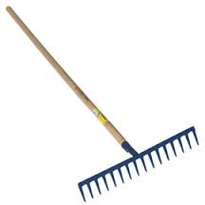.

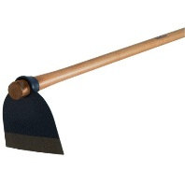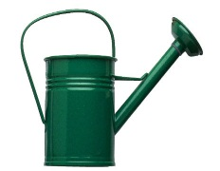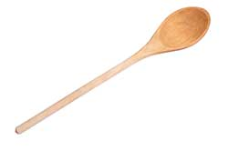

**Ways to keep it going:**

You may find opportunities to talk about tools you use throughout the day.

When we actually use the word “tool” and describe what it does, we are helping to develop our children’s science concepts.

We use tools while combing our hair, cooking, gardening, and fixing things.

When else can you talk about tools to develop your children’s science concepts?

www.earlylit.net