STAR ACTIVITY

You are your child’s star!

This star handout is designed to be used as part of a parent workshop or staff training. It is designed to help adults—library staff, child care providers, parents—think about how they can enrich children’s language and literacy development. We do this by relating the activity to the early literacy skills children need to be ready to learn to read.

The star idea allows you to say, “You are your children’s star. You have the power to help your children enter school ready to learn to read.”

This form was conceived with the idea that workshop participants would go from one station to another, each with a different activity. A blank star handout is given out to each person at each station. The activity station can be a craft, one easily replicated at home, or simulations of what might be happening at home, such as cooking, bath time, or going shopping.

In this document, the first star graphic is the blank that is given to the adults, one per person per station. If you want just this blank, click here for Word, here for pdf.
The remaining pages are examples of activities and a few examples of ways to support early literacy. There are, of course, many more options for both the activity stations and for ways to support early literacy.

It is helpful to let participants know that some activities lend themselves more easily to some of the skills than others. This is a brainstorming activity that can lead to sharing experiences and to some good discussion.

Have fun!

www.earlylit.net
Connecting Activities
to Early Literacy

YOU
Notice print,
handling books
Explore letters
Explore sounds,
rhyming
Know and share information
Build words
Tell & retell stories and events

www.earlylit.net
Cooking or Meal Time

May include: pots, pans, measuring cups, utensils, plates, silverware, food
What words might you add that your children do not know? Can you add words that describe—taste, texture?
Words for measurement—fill it three-quarters full.
Have child tell what they are doing in sequence, in order. What will we do next?
Talk about memories—have child tell you . . . remember when . . .

YOU
Notice print,
handling books
Explore letters
Explore sounds,
rhyming
Know and share information
Build words
Tell & retell stories and events

Is there a recipe? If so, can point out some letters.
If not, maybe write a recipe.
Talk about shapes you see.
Compare how two things look similar or different.
Magnet letters on fridge.
Children’s writing on fridge. Leave notes to children on fridge.

What is that steam?
What tastes go well together?
Talk about a topic of interest to you or your child. Share factual information. What don’t you know the answers to; where can you find out?

Maybe your child is pretending this is a restaurant. What is the name of the restaurant? Make a sign. Need a menu?
An interesting placemat—what does it say/
Listen to cooking sounds—water boiling
What kind of music and rhythm can you make with pots and utensils?
Sing a song—This is the way we . . .

www.earlylit.net
Make a Puppet

Make a puppet using paper and markers/crayons.
Have the child tell a story with the puppets they have made.
Adult adds less familiar words, building on what the child has said.
Adult asks open-ended questions to build on the story, build imagination. Follows child’s lead.

YOU
Notice print,
handling books
Explore letters
Explore sounds,
rhyming
Know and share information
Build words
Tell & retell stories and events

When following the child’s story, is there any factual information you might add?
What questions can you ask to support problem-solving?
Talk about shapes you see in the child’s drawing.
Child can write/scribble own name or name of character.

What signs might you make to support what the child’s story is about?

Are any of the puppets animals? What sounds do they make?
In the story, are there any environmental sounds, like a doorbell, or sound of a car or airplane? Add these sounds.
Does any character sing a song?

www.earlylit.net

Factual Books
Make-a-Book

Display of factual books for young children.
Make a Book from a sheet of paper.
Make a book from ziplock bags for babies.

Explore interesting words found in factual books
Draw a story in your book, tell the story.
Draw what you know on a factual topic.

YOU
Notice print,
handling books
Explore letters
Explore sounds,
rhyming
Know and share information
Build words
Tell & retell stories and events

Sharing informational books builds children’s background knowledge, knowledge about the world. Discuss what you know and what the child knows on the topic.
Use own book as an opportunity to share information on topic.
Talk about the letters in a word of interest to the child.
Have child write/scribble name for the book they make.
Adult can write some words the child says and spell them.

Making a book helps children learn how books work, direction of text, title page, author and illustrator
Factual books may have table of contents, glossary, picture captions, index.
Book child makes may include rhyming words, sounds of animals or other environmental sounds, alliteration.

www.earlylit.net

Talk with child about what they are making, adding new words and ideas.
Encourage child to tell story or tell you what they are doing with the blocks.
Make comments or ask questions to encourage problem solving and imaginative play.
Block Play

Use containers like cereal boxes, cans, etc.

YOU
Notice print,
handling books
Explore letters
Explore sounds,
rhyming
Know and share information
Build words
Tell & retell stories and events

Talk about shapes.
Talk about turning blocks around different ways, how they fit.
Talk about how blocks or structures look similar and different.
Play matching games.
What information can be added to what they know? To what they are telling you?
Ask questions to explore balance, what blocks of different sizes or shapes can do, how they work together or not. Engage child in problem solving.

What is the child making? Can you add signs or logos or other printed materials to their play?
What sounds can be added to their play?

www.earlylit.net
Make a Talking Puppet

You can use this pattern to make all kinds of puppets that can talk. Encourage your child to make the puppet talk. In this way your child develops narrative skills, the ability to say what happens and to tell stories. You can make puppets for everyone, including yourself!

Use 8 ½” x 11” paper.

1. Fold into thirds 2. Fold in half 3. Fold each half
backwards

4. Color your puppet.
Put your fingers in the top opening and your thumb in the bottom opening.

www.earlylit.net
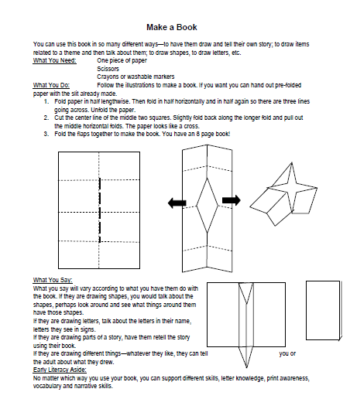
www.earlylit.net

